COMPUTER COMMUNICATION

UNIT I

Evolution of Computer Networks
- The term computer networks resulted from the 'combination of two major areas, namely computers and communications.
- It was during the 1950's, that computers were treated as large complex machines and were operated by specially trained people. Jobs were given to computers in the form of batches. Punched cards, paper tapes, or magnetic tapes were used as input devices. There was no direct communication or interaction between the user and the computer. Users suffered with extremely long delays between the submission of jobs and the receipt of output results. The computer model resembles the one shown in Figure. Note that there are two queues, one at the input device and another at the output device.
- In the 1960's, interactive terminals were developed. Remote users can be connected to a large mainframe computer via a low speed data line. The network resembles the one shown in Figure.
- When more devices are' connected to a computer, it is not so economical to have a separate communication line from each device to the computer. To solve this problem, multiplexers and concentrators were developed. These devices collect the output from a set of peripheral devices and send it over a common communication link. Special communication processors called front-ends were developed to relieve the mainframe computers from performing all the communication functions.
- Time-sharing systems were developed and that led to the development of many applications centered on a single computer. The concept of a large-scale, general-purpose network was developed. Such a network consists of a set of nodes called network switches or interface message processors (IMP) connected by means of interconnecting transmission links. Interconnecting links can be a wire, microwave radio, optical fiber, or satellite communication links. Nodes are located at geographically separated locations. Each node forwards the message passing through it to the next node in the concerned path.
- As technology advanced, inexpensive personal computers started replacing medium and large systems in many commercial and educational institutions. Local Area Networks (LAN) were developed. A LAN is capable of sharing expensive resources like laser printers, enterprise software, etc., and provides access to a large database. LANs were initially used for the purpose of connecting people. It supports high speed switching. Special software known as Network OS was developed to manage and control the access of these Local Area Networks. The users demanded access to resources outside the LAN. The most common resources were printers and large databases. These resources may be components of other LAN. Remote file transfer and remote login were then developed. The concept of Wide Area Networking (WAN) evolved by interconnecting hundreds of thousands of Local Area Networks
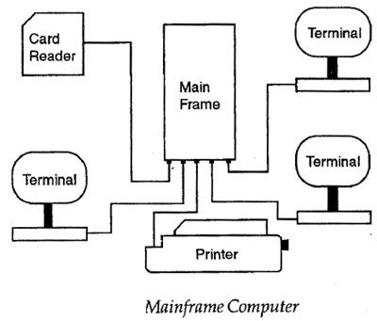
Networks categories:
The Network allows computers to connect and communicate with different computers via any medium. LAN, MAN and WAN are the three major types of the network designed to operate over the area they cover. There are some similarities and dissimilarities between them. One of the major differences is the geographical area they cover, i.e. LAN covers the smallest area; MAN covers an area larger than LAN and WAN comprises the largest of all.
There are other types of Computer Networks also, like :
- PAN (Personal Area Network)
- SAN (Storage Area Network)
- EPN (Enterprise Private Network)
- VPN (Virtual Private Network)

Local Area Network (LAN) –
LAN or Local Area Network connects network devices in such a way that personal computer and workstations can share data, tools and programs. The group of computers and devices are connected together by a switch, or stack of switches, using a private addressing scheme as defined by the TCP/IP protocol. Private addresses are unique in relation to other computers on the local network. Routers are found at the boundary of a LAN, connecting them to the larger WAN.
Data transmits at a very fast rate as the number of computers linked are limited. By definition, the connections must be high speed and relatively inexpensive hardware (Such as hubs, network adapters and Ethernet cables). LANs cover smaller geographical area (Size is limited to a few kilometers) and are privately owned. One can use it for an office building, home, hospital, schools, etc. LAN is easy to design and maintain. A Communication medium used for LAN has twisted pair cables and coaxial cables. It covers a short distance, and so the error and noise are minimized.
Early LAN’s had data rates in the 4 to 16 Mbps range. Today, speeds are normally 100 or 1000 Mbps. Propagation delay is very short in a LAN. The smallest LAN may only use two computers, while larger LANs can accommodate thousands of computers. A LAN typically relies mostly on wired connections for increased speed and security, but wireless connections can also be part of a LAN. The fault tolerance of a LAN is more and there is less congestion in this network. For example : A bunch of students playing Counter Strike in the same room (without internet).
Metropolitan Area Network (MAN) –
MAN or Metropolitan area Network covers a larger area than that of a LAN and smaller area as compared to WAN. It connects two or more computers that are apart but resides in the same or different cities. It covers a large geographical area and may serve as an ISP (Internet Service Provider). MAN is designed for customers who need a high-speed connectivity. Speeds of MAN ranges in terms of Mbps. It’s hard to design and maintain a Metropolitan Area Network.
The fault tolerance of a MAN is less and also there is more congestion in the network. It is costly and may or may not be owned by a single organization. The data transfer rate and the propagation delay of MAN is moderate. Devices used for transmission of data through MAN are: Modem and Wire/Cable. Examples of a MAN are the part of the telephone company network that can provide a high-speed DSL line to the customer or the cable TV network in a city.
Wide Area Network (WAN) –
WAN or Wide Area Network is a computer network that extends over a large geographical area, although it might be confined within the bounds of a state or country. A WAN could be a connection of LAN connecting to other LAN’s via telephone lines and radio waves and may be limited to an enterprise (a corporation or an organization) or accessible to the public. The technology is high speed and relatively expensive.
There are two types of WAN: Switched WAN and Point-to-Point WAN. WAN is difficult to design and maintain. Similar to a MAN, the fault tolerance of a WAN is less and there is more congestion in the network. A Communication medium used for WAN is PSTN or Satellite Link. Due to long distance transmission, the noise and error tend to be more in WAN.
WAN’s data rate is slow about a 10th LAN’s speed, since it involves increased distance and increased number of servers and terminals etc. Speeds of WAN ranges from few kilobits per second (Kbps) to megabits per second (Mbps). Propagation delay is one of the biggest problems faced here. Devices used for transmission of data through WAN are: Optic wires, Microwaves and Satellites. Example of a Switched WAN is the asynchronous transfer mode (ATM) network and Point-to-Point WAN is dial-up line that connects a home computer to the Internet.

Data transmission modes:
Simplex, Half Duplex, Full Duplex
Simplex
In simplex transmission mode, the communication between sender and receiver occurs in only one direction. The sender can only send the data, and the receiver can only receive the data. The receiver cannot reply to the sender.
Simplex transmission can be thought of as a one-way road in which the traffic travels only in one direction—no vehicle coming from the opposite direction is allowed to drive through.
To take a keyboard / monitor relationship as an example, the keyboard can only send the input to the monitor, and the monitor can only receive the input and display it on the screen. The monitor cannot reply, or send any feedback, to the keyboard.
Half Duplex
The communication between sender and receiver occurs in both directions in half duplex transmission, but only one at a time. The sender and receiver can both send and receive the information, but only one is allowed to send at any given time. Half duplex is still considered a one-way road, in which a vehicle traveling in the opposite direction of the traffic has to wait till the road is empty before it can pass through.
For example, in walkie-talkies, the speakers at both ends can speak, but they have to speak one by one. They cannot speak simultaneously.
Full Duplex
In full duplex transmission mode, the communication between sender and receiver can occur simultaneously. The sender and receiver can both transmit and receive at the same time. Full duplex transmission mode is like a two-way road, in which traffic can flow in both directions at the same time.
For example, in a telephone conversation, two people communicate, and both are free to speak and listen at the same time.

Types of Network Topology
a) Mesh Topology :
In mesh topology, every device is connected to another device via particular channel.
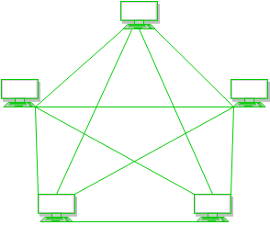
If suppose, N number of devices are connected with each other in mesh topology, then total number of ports that is required by each device is ​ N-1. In the Figure 1, there are 5 devices connected to each other, hence total number of ports required is 4.
If suppose, N number of devices are connected with each other in mesh topology, then total number of dedicated links required to connect them is NC2 i.e. N(N-1)/2. In the Figure 1, there are 5 devices connected to each other, hence total number of links required is 5*4/2 = 10.

Advantages of this topology :

- It is robust.
- Fault is diagnosed easily. Data is reliable because data is transferred among the devices through dedicated channels or links.
- Provides security and privacy.
- Problems with this topology :
- Installation and configuration is difficult.
- Cost of cables are high as bulk wiring is required, hence suitable for less number of devices.
- Cost of maintenance is high.

b) Star Topology :
​ In star topology, all the devices are connected to a single hub through a cable. This hub is the central node and all others nodes are connected to the central node. The hub can be passive ​in nature i.e. not intelligent hub such as broadcasting devices, at the same time the hub can be intelligent known as active ​hubs. Active hubs have repeaters in them.
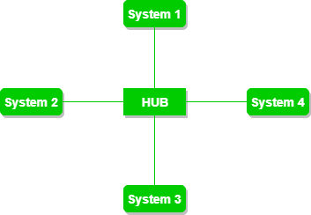
Advantages of this topology :
- If N devices are connected to each other in star topology, then the number of cables required to connect them is N. So, it is easy to set up.
- Each device require only 1 port i.e. to connect to the hub.
Problems with this topology :

- If the concentrator (hub) on which the whole topology relies fails, the whole system will crash down.
- Cost of installation is high.
- Performance is based on the single concentrator i.e. hub.

c) Bus Topology :
​ Bus topology is a network type in which every computer and network device is connected to single cable. It transmits the data from one end to another in single direction. No bi-directional feature is in bus topology.
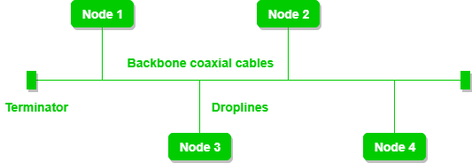
If N devices are connected to each other in bus topology, then the number of cables required to connect them is 1 ​which is known as backbone cable and N drop lines are required.
Cost of the cable is less as compared to other topology, but it is used to built small networks.
Problems with this topology :
- If the common cable fails, then the whole system will crash down.
- If the network traffic is heavy, it increases collisions in the network. To avoid this, various protocols are used in MAC layer known as Pure Aloha, Slotted Aloha, CSMA/CD etc.
d) Ring Topology :

​ In this topology, it forms a ring connecting a devices with its exactly two neighbouring devices.
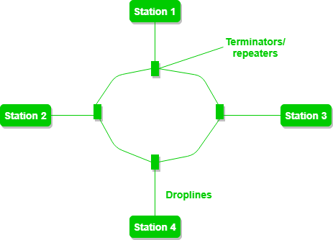
The following operations takes place in ring topology are :
One station is known as monitor station which takes all the responsibility to perform the operations.
To transmit the data, station has to hold the token. After the transmission is done, the token is to be released for other stations to use.
When no station is transmitting the data, then the token will circulate in the ring.
There are two types of token release techniques : Early token release releases the token just after the transmitting the data and Delay token release releases the token after the acknowledgement is received from the receiver.
Advantages of this topology :
- The possibility of collision is minimum in this type of topology.
- Cheap to install and expand.
Problems with this topology :
Troubleshooting is difficult in this topology.
Addition of stations in between or removal of stations can disturb the whole topology.
e) Hybrid Topology :
​This topology is a collection of two or more topologies which are described above. This is a scalable topology which can be expanded easily. It is reliable one but at the same it is a costly topology.

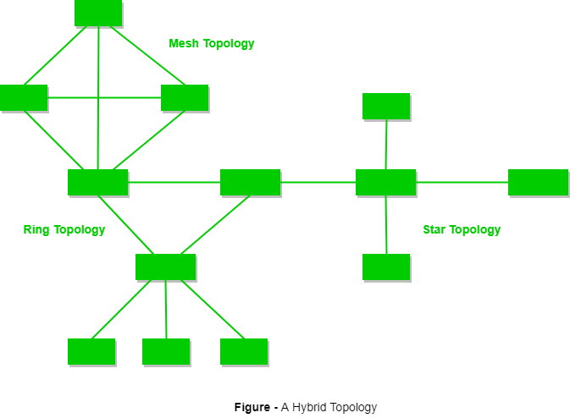

Circuit Switching VS Packet Switching
Circuit switching is referred to as the technology of data transfer that utilises sending messages from one point to another. This involves sending messages from the receiver to the sender and back simultaneously. A physical connection gets established during this process along with the receiver; a dedicated circuit is always present to handle data transmissions, through which data is sent. Packet switching can be used as an alternative to circuit switching. In the packet-switched networks, data is sent in discrete units that have variable length.

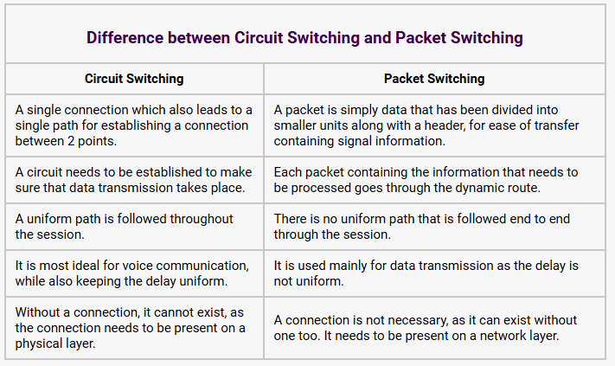
https://www.geeksforgeeks.org/difference-between-circuit-switching-and-packet-switching/

Protocols and standards
In telecommunications, a communication protocol is a system of rules that allows two or more entities of a communications system to transmit information via any kind of variation of a physical quantity. These are the rules or standard that defines the syntax, semantics and synchronization of communication and possible error recovery methods. Protocols may be implemented by hardware, software, or a combination of both.
Communicating systems use well-defined formats (protocol) for exchanging messages. Each message has an exact meaning intended to elicit a response from a range of possible responses pre-determined for that particular situation.
Standards are guidelines, these are more abstract. You can have products that meet the standard, exceed the standard or below a certain standard.
Protocols are rules. They define exactly how data is exchanged and the expected behavior. These are rules you must follow exactly or your device will not be able to communicate at all with other devices. You cannot exceed the protocol but it’s possible that you do not implement all the features of the protocols or you may implement the protocol completely.

OSI Model
- OSI stands for Open System Interconnection is a reference model that describes how information from a software application in one computer moves through a physical medium to the software application in another computer.
- OSI consists of seven layers, and each layer performs a particular network function.
- OSI model was developed by the International Organization for Standardization (ISO) in 1984, and it is now considered as an architectural model for the inter-computer communications.
- OSI model divides the whole task into seven smaller and manageable tasks. Each layer is assigned a particular task.
- Each layer is self-contained, so that task assigned to each layer can be performed independently
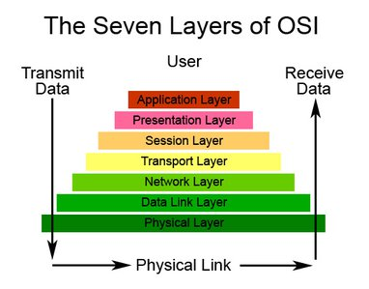

Characteristics of OSI Model:

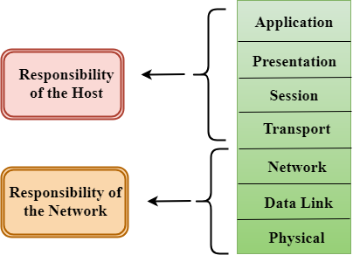
- The OSI model is divided into two layers: upper layers and lower layers.
- The upper layer of the OSI model mainly deals with the application related issues, and they are implemented only in the software. The application layer is closest to the end user. Both the end user and the application layer interact with the software applications. An upper layer refers to the layer just above another layer.
- The lower layer of the OSI model deals with the data transport issues. The data link layer and the physical layer are implemented in hardware and software. The physical layer is the lowest layer of the OSI model and is closest to the physical medium. The physical layer is mainly responsible for placing the information on the physical medium.

Functions of the OSI Layers
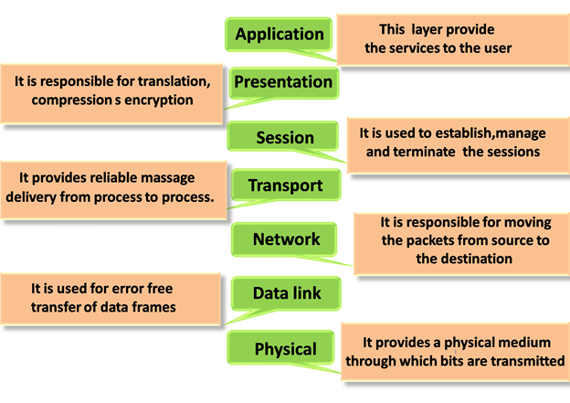

Physical layer

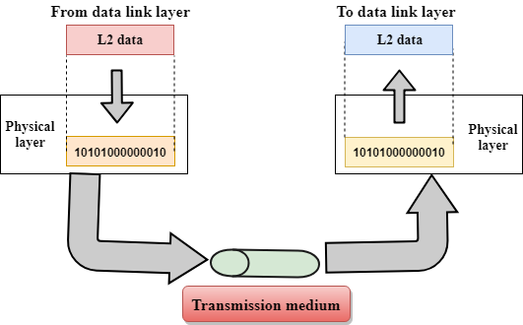
- The main functionality of the physical layer is to transmit the individual bits from one node to another node.
- It is the lowest layer of the OSI model.
- It establishes, maintains and deactivates the physical connection.
- It specifies the mechanical, electrical and procedural network interface specifications.

Functions of a Physical layer:
- Line Configuration: It defines the way how two or more devices can be connected physically.
- Data Transmission: It defines the transmission mode whether it is simplex, half-duplex or full-duplex mode between the two devices on the network.
- Topology: It defines the way how network devices are arranged.
- Signals: It determines the type of the signal used for transmitting the information.

Data-Link Layer
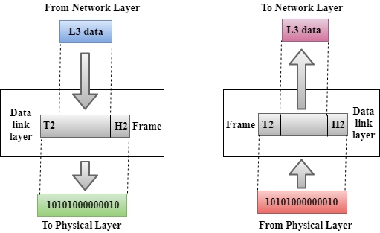
- This layer is responsible for the error-free transfer of data frames.
- It defines the format of the data on the network.
- It provides a reliable and efficient communication between two or more devices.
- It is mainly responsible for the unique identification of each device that resides on a local network.
- It contains two sub-layers:
  - Logical Link Control Layer
    - It is responsible for transferring the packets to the Network layer of the receiver that is receiving.
    - It identifies the address of the network layer protocol from the header.
    - It also provides flow control.
  - Media Access Control Layer
    - A Media access control layer is a link between the Logical Link Control layer and the network's physical layer.
    - It is used for transferring the packets over the network.

Functions of the Data-link layer
- Framing: The data link layer translates the physical's raw bit stream into packets known as Frames. The Data link layer adds the header and trailer to the frame. The header which is added to the frame contains the hardware destination and source address.

- Physical Addressing: The Data link layer adds a header to the frame that contains a destination address. The frame is transmitted to the destination address mentioned in the header.
- Flow Control: Flow control is the main functionality of the Data-link layer. It is the technique through which the constant data rate is maintained on both the sides so that no data get corrupted. It ensures that the transmitting station such as a server with higher processing speed does not exceed the receiving station, with lower processing speed.
- Error Control: Error control is achieved by adding a calculated value CRC (Cyclic Redundancy Check) that is placed to the Data link layer's trailer which is added to the message frame before it is sent to the physical layer. If any error seems to occurr, then the receiver sends the acknowledgment for the retransmission of the corrupted frames.
- Access Control: When two or more devices are connected to the same communication channel, then the data link layer protocols are used to determine which device has control over the link at a given time.

Network Layer
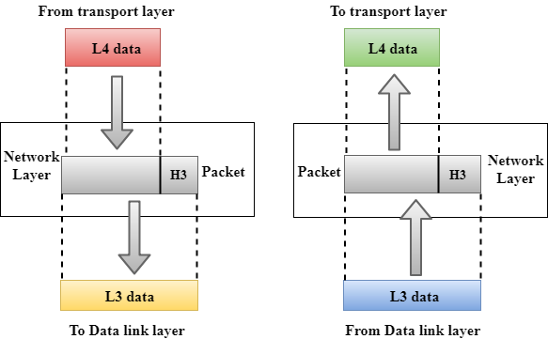
- It is a layer 3 that manages device addressing, tracks the location of devices on the network.
- It determines the best path to move data from source to the destination based on the network conditions, the priority of service, and other factors.
- The Data link layer is responsible for routing and forwarding the packets.
- Routers are the layer 3 devices, they are specified in this layer and used to provide the routing services within an internetwork.
- The protocols used to route the network traffic are known as Network layer protocols. Examples of protocols are IP and Ipv6.

Functions of Network Layer:
- Internetworking: An internetworking is the main responsibility of the network layer. It provides a logical connection between different devices.
- Addressing: A Network layer adds the source and destination address to the header of the frame. Addressing is used to identify the device on the internet.
- Routing: Routing is the major component of the network layer, and it determines the best optimal path out of the multiple paths from source to the destination.
- Packetizing: A Network Layer receives the packets from the upper layer and converts them into packets. This process is known as Packetizing. It is achieved by internet protocol (IP).

Transport Layer
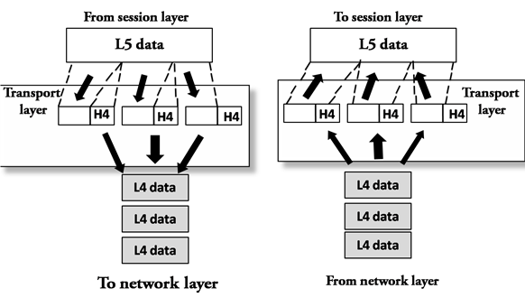
- The Transport layer is a Layer 4 ensures that messages are transmitted in the order in which they are sent and there is no duplication of data.
- The main responsibility of the transport layer is to transfer the data completely.
- It receives the data from the upper layer and converts them into smaller units known as segments.
- This layer can be termed as an end-to-end layer as it provides a point-to-point connection between source and destination to deliver the data reliably.
The two protocols used in this layer are:
- Transmission Control Protocol
  - It is a standard protocol that allows the systems to communicate over the internet.
  - It establishes and maintains a connection between hosts.
  - When data is sent over the TCP connection, then the TCP protocol divides the data into smaller units known as segments. Each segment travels over the internet using multiple routes, and they arrive in different orders at the destination. The transmission control protocol reorders the packets in the correct order at the receiving end.
- User Datagram Protocol
  - User Datagram Protocol is a transport layer protocol.
  - It is an unreliable transport protocol as in this case receiver does not send any acknowledgment when the packet is received, the sender does not wait for any acknowledgment. Therefore, this makes a protocol unreliable.

Functions of Transport Layer:
- Service-point addressing: Computers run several programs simultaneously due to this reason, the transmission of data from source to the destination not only from one computer to another computer but also from one process to another process. The transport layer adds the header that contains the address known as a service-point address or port address. The responsibility of the network layer is to transmit the data from one computer to another computer and the responsibility of the transport layer is to transmit the message to the correct process.
- Segmentation and reassembly: When the transport layer receives the message from the upper layer, it divides the message into multiple segments, and each segment is assigned with a sequence number that uniquely identifies each segment. When the message has arrived at the destination, then the transport layer reassembles the message based on their sequence numbers.
- Connection control: Transport layer provides two services Connection-oriented service and connectionless service. A connectionless service treats each segment as an individual packet, and they all travel in different routes to reach the destination. A connection-oriented service makes a connection with the transport layer at the destination machine before delivering the packets. In connection-oriented service, all the packets travel in the single route.
- Flow control: The transport layer also responsible for flow control but it is performed end-to-end rather than across a single link.
- Error control: The transport layer is also responsible for Error control. Error control is performed end-to-end rather than across the single link. The sender transport layer ensures that message reach at the destination without any error.

Session Layer
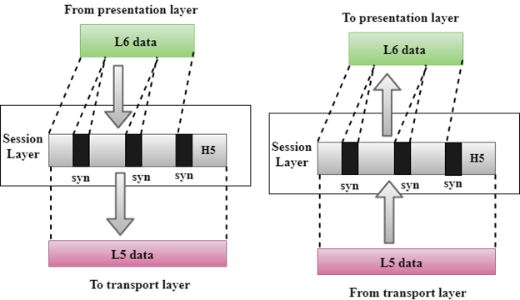
- It is a layer 3 in the OSI model.
- The Session layer is used to establish, maintain and synchronizes the interaction between communicating devices.

Functions of Session layer:
- Dialog control: Session layer acts as a dialog controller that creates a dialog between two processes or we can say that it allows the communication between two processes which can be either half-duplex or full-duplex.
- Synchronization: Session layer adds some checkpoints when transmitting the data in a sequence. If some error occurs in the middle of the transmission of data, then the transmission will take place again from the checkpoint. This process is known as Synchronization and recovery.

Presentation Layer
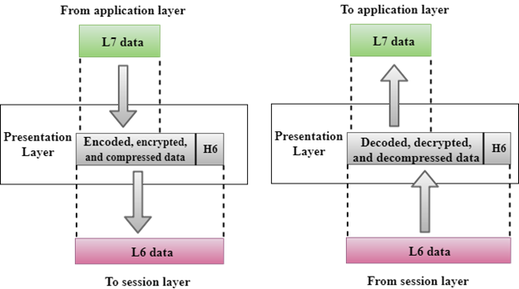
- A Presentation layer is mainly concerned with the syntax and semantics of the information exchanged between the two systems.
- It acts as a data translator for a network.
- This layer is a part of the operating system that converts the data from one presentation format to another format.
- The Presentation layer is also known as the syntax layer.

Functions of Presentation layer:
- Translation: The processes in two systems exchange the information in the form of character strings, numbers and so on. Different computers use different encoding methods, the presentation layer handles the interoperability between the different encoding methods. It converts the data from sender-dependent format into a common format and changes the common format into receiver-dependent format at the receiving end.
- Encryption: Encryption is needed to maintain privacy. Encryption is a process of converting the sender-transmitted information into another form and sends the resulting message over the network.
- Compression: Data compression is a process of compressing the data, i.e., it reduces the number of bits to be transmitted. Data compression is very important in multimedia such as text, audio, video.

Application Layer
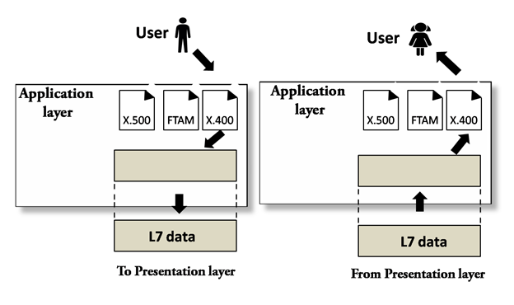
- An application layer serves as a window for users and application processes to access network service.
- It handles issues such as network transparency, resource allocation, etc.
- An application layer is not an application, but it performs the application layer functions.
- This layer provides the network services to the end-users.

Functions of Application layer:
- File transfer, access, and management (FTAM): An application layer allows a user to access the files in a remote computer, to retrieve the files from a computer and to manage the files in a remote computer.
- Mail services: An application layer provides the facility for email forwarding and storage.
- Directory services: An application provides the distributed database sources and is used to provide that global information about various objects.

TCP/IP Protocol Suite:
The Transmission Control Protocol/ Internet Protocol suite of protocol form the basis of the internet. It is TCP/IP that creates a virtual network when multiple computer networks are connected together. The TCP/IP networks was earlier known as ARPANET, but is now known as internet.
TCP/IP Suite consists of Four layer Network Interface: -
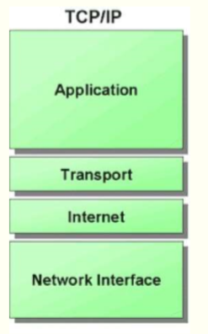
network interface:
It include the function of physical layer and data link layer. TCP/IP protocol suite includes Host-to-network layer protocols such as Serial Line internet protocol and point to point protocol
Internet Layer: - The internet layer is exactly same to the network layer of OSI model. IP is the primary protocol operating at this layer and it provides data encapsulation routing, addressing and fragmentation services to the protocols at the transport layer above it.
Transport Layer: - TCP/IP Suite includes two protocol at this layer, the transmission control protocol and the user datagram protocol These protocol provides connection or connectionless data transfer services. Application layer: - The TCP/IP protocol at the application layer can take different forms of Protocols, such as the File Transfer Protocol, Hypertext Transfer Protocol.
Network Interface Layer
It is the bottom layer of TCP/IP Model lies below the Internet Layer. • It is also known as Host To Network Layer • Function of this layer is to connect the Host To Network & inform the upper layers so that they could start sending the data packets. • This layer varies from network to network. • Host To Network Layer protocols • SLIP(Serial Line IP ) • PPP( Point To Point Protocol )
Serial line Internet protocol is very simple and used to connect the workstation to internet over dial-up line using a modem.  SLIP(Serial line Internet protocol ) is not a standard protocol for carrying IP Packets over the a serial line between a home user and The ISP server. But , it has become popular because of its simplicity .  The role of SLIP begins only when there is a proper connection between the two modem
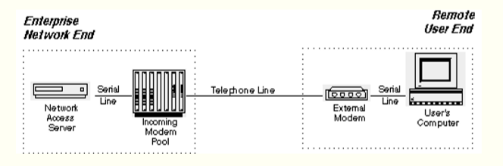
It is not an approved internet standard. • It does not provide any authentication. • SLIP provides no way for the two devices to communicate control information between them to manage the link. • SLIP doesn't provide any way of detecting or correcting errors in transmissions
Point to Point Protocol ( PPP )
Point to Point Protocol is a data link layer Protocol.  PPP is another examples of the evolving the nature of internet.  It has become standard internet protocol for remote access, using dial-up connection.  The basic Functionality of PPP is similar to the SLIP.  It passes the and other packets in the form of frames between a client and ISP Server.  PPP is more complex than SLIP.
Line control Protocol(LCP): - The Line control protocol is responsible for establishing , maintaining the connection between the Two end ( Home User and the ISP ) • Password Authentication Protocol( PAP ) : - password authentication protocol is used. • Here the user must establish a proof of identity , so that he can connect to ISP. • Network Control protocol ( NCP ): - Once the Authentication is done, PPP on the client side sends out a NCP packet. This packet tells the ISP server what kind of traffic is to be passed over this PPP link. • IP Control Protocol ( IPCP ) : - the IP Control Protocol takes over. Here , actual IP packet are now exchanged. IPCP establishes the connection between the Host user and ISP.
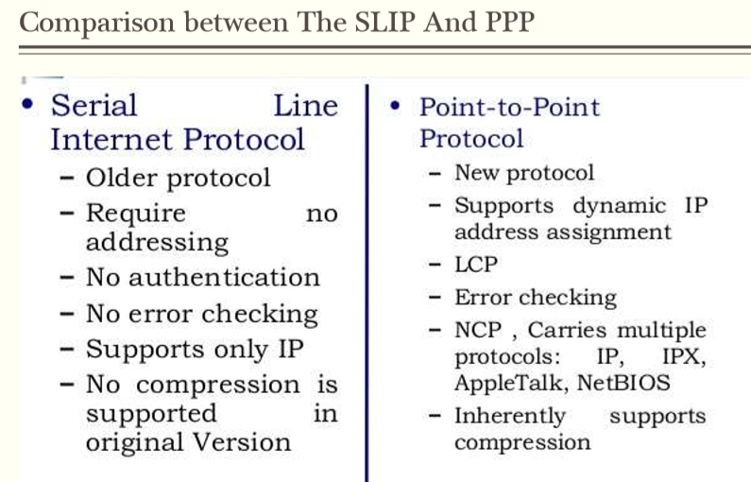
Internet Layer
The fives network layer protocol are as follows:1. ARP 2. RARP 3. IP 4. ICMP 5. IGMP IP is an Important protocol in this layer. ARP ( Address resolution protocol ) ✓ Every machine on internet has one address, these address cannot actually be used for sending packets data because data link layer does not understand the internet address. ✓ ARP Provides an essential services when TCP/IP is running in LAN.
RARP ( Reverse Address Resolution Protocol )
The Reverse Address Resolution Protocol is used to obtain the IP address of a Host based on Its physical address. That is , it preform a job that is exactly opposite to that of ARP.  RARP works in a very similar way to ARP. but in the exactly opposite direction , as shown in the side figure.
Internet Protocol ( IP )
• Internet Protocol is very important protocol present in this network layer. • IP is the protocol responsible for carrying data, generated by nearly all the other TCP/IP protocol, from the source system to its destination .
Transport Layer ( TCP and UDP )
The transport layer runs on the top of internet layer and is mainly concerned with transport of packets from the source to the destination. ➢ The main function of transport layer is to deliver packets between the end points. ➢ In TCP/IP, the transport layer include to protocols : TCP and UDP.
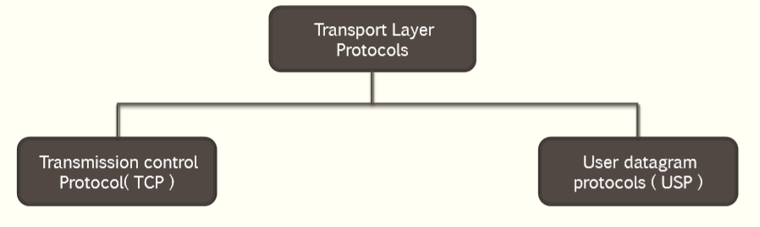
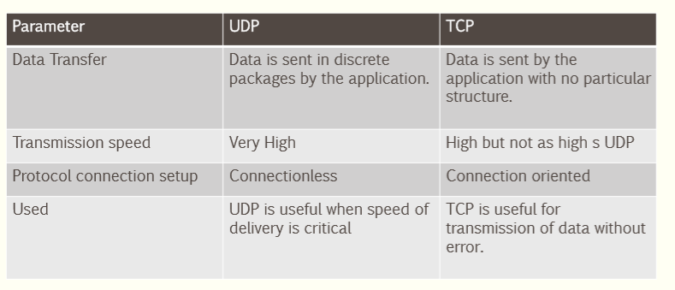
Application Layer
The TCP/IP Model Does Not have Session or presentation layer on the top of the transport layer.  It is just has the application layer. It contains all higher level protocols.  Higher Level Protocols Used in application layer are as Follows:
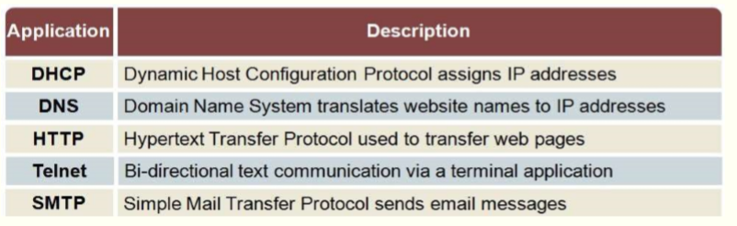
- TELNET: - the virtual terminal protocol allows a user on one machine to log onto a distant machine and work there.
- FTP: - File Transfer protocol provides a way to move data efficiently from one machine to another.
- SMTP: - Simple mail transfer protocol developed for email transfer.
- DNS: -Domain Name System Protocol is used for mapping the host names onto their network address.
- HTTP: -hyper Text transfer Protocol is used for fetching pages on the world wide web (WWW) and many others.
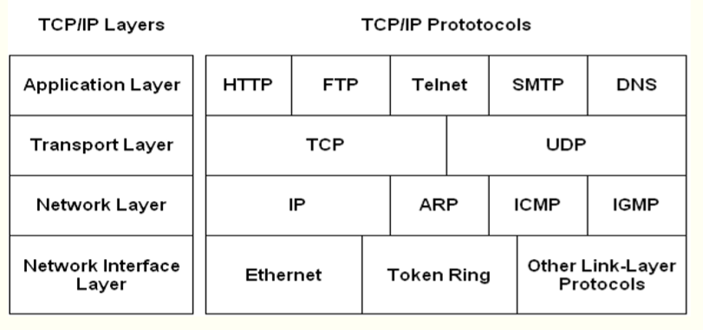
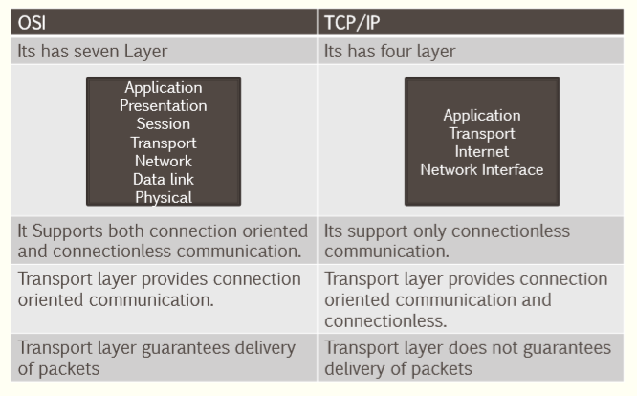

Serial and Parallel Transmission

When data is sent or received using serial data transmission, the data bits are organized in a specific order, since they can only be sent one after another. The order of the data bits is important as it dictates how the transmission is organized when it is received. It is viewed as a reliable data transmission method because a data bit is only sent if the previous data bit has already been received.

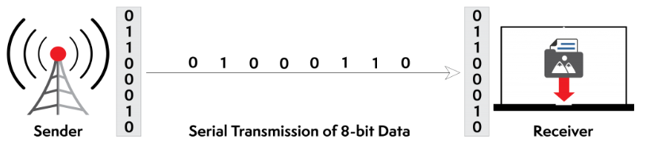
Serial transmission has two classifications: asynchronous and synchronous.

Asynchronous Serial Transmission

Data bits can be sent at any point in time. Stop bits and start bits are used between data bytes to synchronize the transmitter and receiver and to ensure that the data is transmitted correctly. The time between sending and receiving data bits is not constant, so gaps are used to provide time between transmissions.

The advantage of using the asynchronous method is that no synchronization is required between the transmitter and receiver devices. It is also a more cost effective method. A disadvantage is that data transmission can be slower, but this is not always the case.
Synchronous Serial Transmission
Data bits are transmitted as a continuous stream in time with a master clock. The data transmitter and receiver both operate using a synchronized clock frequency; therefore, start bits, stop bits, and gaps are not used. This means that data moves faster and timing errors are less frequent because the transmitter and receiver time is synced. However, data accuracy is highly dependent on timing being synced correctly between devices. In comparison with asynchronous serial transmission, this method is usually more expensive.

parallel transmission
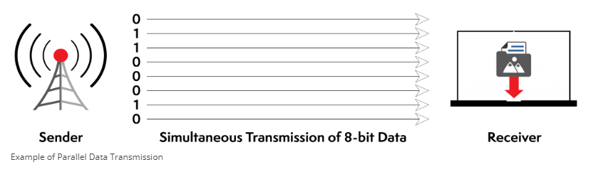
When data is sent using parallel data transmission, multiple data bits are transmitted over multiple channels at the same time. This means that data can be sent much faster than using serial transmission methods.
Given that multiple bits are sent over multiple channels at the same time, the order in which a bit string is received can depend on various conditions, such as proximity to the data source, user location, and bandwidth availability. Two examples of parallel interfaces can be seen below. In the first parallel interface, the data is sent and received in the correct order. In the second parallel interface, the data is sent in the correct order, but some bits were received faster than others.

Advantages and Disadvantages of Using Parallel Data Transmission
The main advantages of parallel transmission over serial transmission are:
- it is easier to program;
- and data is sent faster.
Although parallel transmission can transfer data faster, it requires more transmission channels than serial transmission. This means that data bits can be out of sync, depending on transfer distance and how fast each bit loads. A simple of example of where this can be seen is with a voice over IP (VOIP) call when distortion or interference is noticeable. It can also be seen when there is skipping or interference on a video stream.
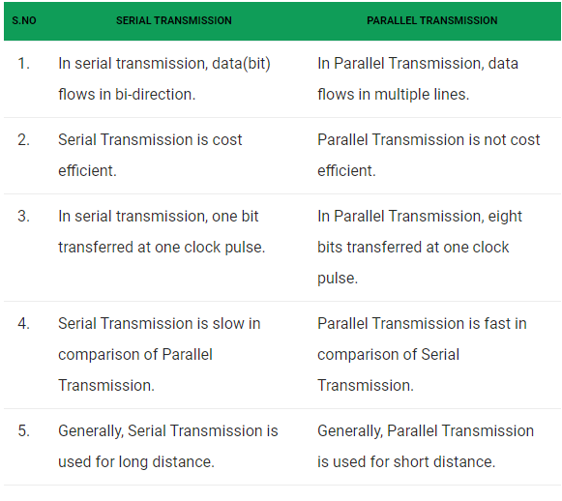
Addressing
It is worth mentioning another concept related to protocol layering in the Internet, addressing. As we discussed before, we have logical communication between pairs of layers in this model. Any communication that involves two parties needs two addresses: source address and destination address. Although it looks as if we need five pairs of addresses, one pair per layer, we normally have only four because the physical layer does not need addresses; the unit of data exchange at the physical layer is a bit, which definitely cannot have an address. Figure 2.9 shows the addressing at each layer. As the figure shows, there is a relationship between the layer, the address used in that layer, and the packet name at that layer. At the application layer, we normally use names to define the site that provides services, such as someorg.com, or the e-mail
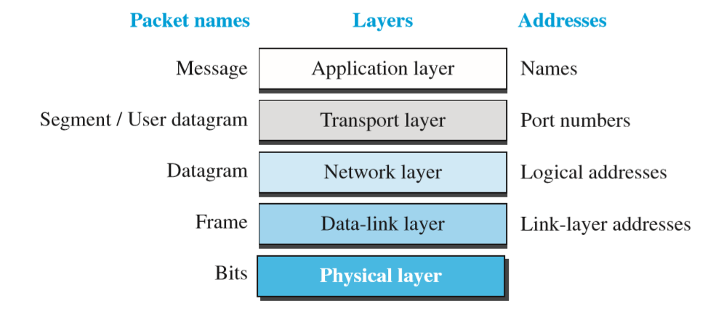
address, such as somebody@coldmail.com. At the transport layer, addresses are called port numbers, and these define the application-layer programs at the source and destination. Port numbers are local addresses that distinguish between several programs running at the same time. At the network-layer, the addresses are global, with the whole Internet as the scope. A network-layer address uniquely defines the connection of a device to the Internet. The link-layer addresses, sometimes called MAC addresses, are locally defined addresses, each of which defines a specific host or router in a network (LAN or WAN

